Chapter 19, Problem 40.

Using Fig. 19.97, design a problem to help other students to better understand how to find g parameters in an ac circuit.

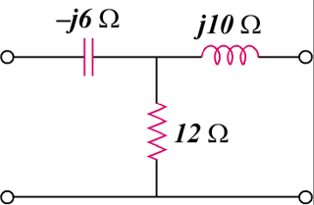
–jX_{C}
jX_{L}
R

Figure 19.97
For Prob. 19.40.

